Dear School Parents/Guardians,
Today your child learned to save lives and reduce disability from strokes through Stroke Smart training! Your child is bringing you a Stroke Smart magnet and wallet card to help you learn how to recognize the signs of a stroke.
Strokes—brain damage caused by a lack of blood flow—are the #1 cause of permanent disability in the U.S., striking one in six of us.
Stroke signs can come and go, and they begin suddenly. If you spot even one of these sudden, unexplained stroke signs, call 911 immediately!

- Balance problems/dizziness
- Sudden vision changes, i.e. double vison, blindness, etc.
- Facial drooping

- One-sided body weakness
- Difficulty understanding speech
- Difficulty speaking

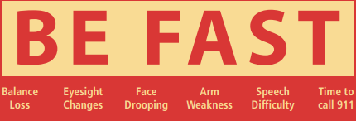

Treatments to restore blood flow and save the brain are effective but are incredibly time sensitive. As soon as you spot a stroke, call 9-1-1. Don’t drive to the hospital (not all hospitals can treat strokes!) and don’t call your doctor—do call 9-1-1. The sooner you get to the hospital, the more likely you are to avoid serious health issues.
For parents of the youngest students, please be sure to teach your child how to use your phone to call 911.
To All Our Good Health!

