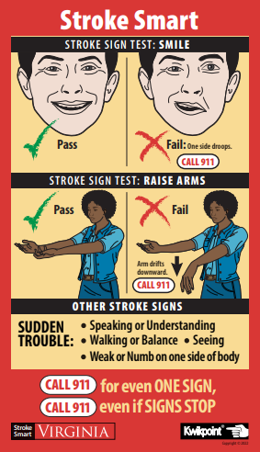
Stroke Smart Lesson Plan Outline
Grades K-4

Review 911 Basics:
What is an emergency?
Can you think of some emergencies where you would need an ambulance?
What do you have to do to get an ambulance to come?
Show me how to make the call (model with a cell phone).
What happens when you call 911? Explain that questions will be asked,
including your address and that the person will be taken to see a doctor.
Ask the students if they know their address and encourage them to learn it.

Introduction:
Where is your brain?
What is your brain used for? What does it do?
There is a dangerous emergency called a Stroke that can hurt people’s brains.
You can help someone having a stroke by calling 911 to get an ambulance.
Do any of you know anyone who has suffered a stroke?
What you will learn in the next few minutes can help you save someone’s life if they are having a stroke.

First, Learn How to Spot a Stroke:
If someone starts to look very strange or they start doing strange things or talking funny so you can’t understand them, think hard! They may be having a stroke!

If you Spot any ONE of these SIGNS call 911 NOW. Tell the operator it looks like a Stroke!

If the person has sudden problems with
- Walking or Balance (demonstrate this)
- Seeing (i.e. double vision, blindness, blurry vision)
- Facial drooping (have the kids smile, point out both sides of the face go up)
- Body weakness/numbness (ask the student to raise both arms straight ahead; If one arm drifts down, call 911
- Speaking or understanding

Hands-On Practice Options:

Ask one student to act out several of the signs for the group of other students to identify.
OR
Pair the students for each to act out the signs and the other to identify them, then switch.

Keep and Share:
The wallet card that you just got is made of waterproof and tear-proof paper (try to tear it!). The magnet can go on your refrigerator or most metal objects. Keep them where you will see them and remind yourself of the stroke signs.

Home Assignment: Be a Stroke Champion to help save lives

Take the wallet cards and magnets home with this letter. Show them to your family and friends, and teach them how to Spot a Stroke

